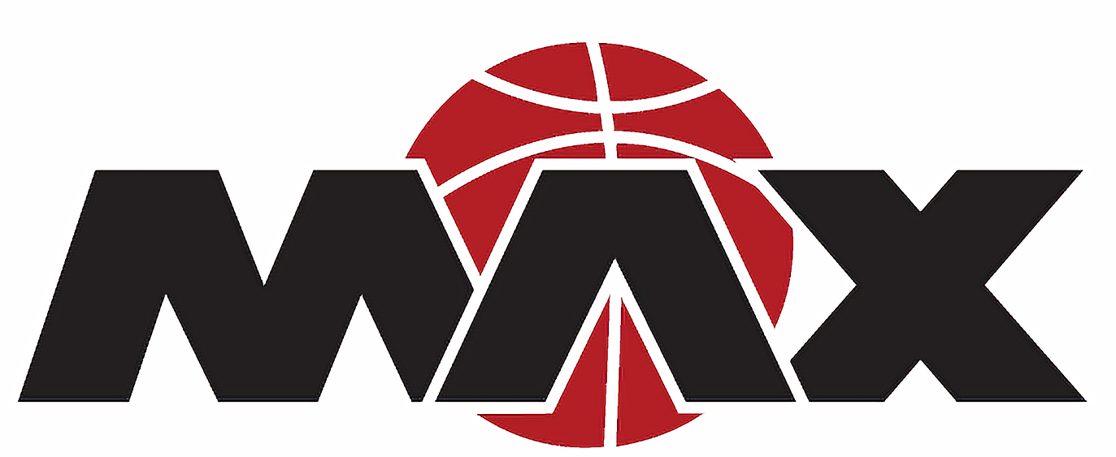
Minnesota MAX Parent Code of Conduct

1. I will encourage good sportsmanship by demonstrating positive support for all players, coaches, contest administrators and officials at every game.
2. I will place the emotional and physical wellbeing of the athletes ahead of my personal desire to win.
3. I will demand a sports environment that is free from drugs, tobacco and alcohol and will refrain from their use at all Minnesota MAX sporting events.
4. I will remember that the game is for the kids - not the adults; and will do my best to make sure that youth sports is a FUN and POSITIVE experience.
5. I will remain mindful that my conduct influences the respect that other athletes, coaches, parents and the public hold for the Minnesota MAX community and athletes.
6. I will treat other players, coaches, fans, volunteers and officials with respect regardless of race, sex, creed or ability.
7. I will not berate the officials!
8. I will not undermine the coaches’ instructions or directions.
9. I will not use profanity!
10. I will calmly communicate my concerns through the proper channels in a dignified and adult manner.

PENALTY
Any violation of the above Code of Conduct may result in a temporary or permanent banishment from any Minnesota MAX sponsored events.
PARENTS, PLEASE BEHAVE OR BE GONE!
YOUR KIDS THANK YOU AND SO DO WE!

